Assignment 6
Experiment 6: Loops (for, while, do-while)
Instructions:
- Prepare a Word or PDF file containing all the given programs implemented in C language.
- Attach clear screenshots of the output for each program in the same Word/PDF file.
- Upload all C programs to your GitHub repository.
- Provide the GitHub repository link in the space given below.
Name: kaveen beniwal
SAP ID: 590032404
Batch: 6
GitHub link: --------------------
Course: B.Tech. CSE (Sem I)
Subject: Programming in C

- Multiplication Table
Write a C program that accepts an integer from the user and displays its multiplication table from 1 to 10 using a for loop.
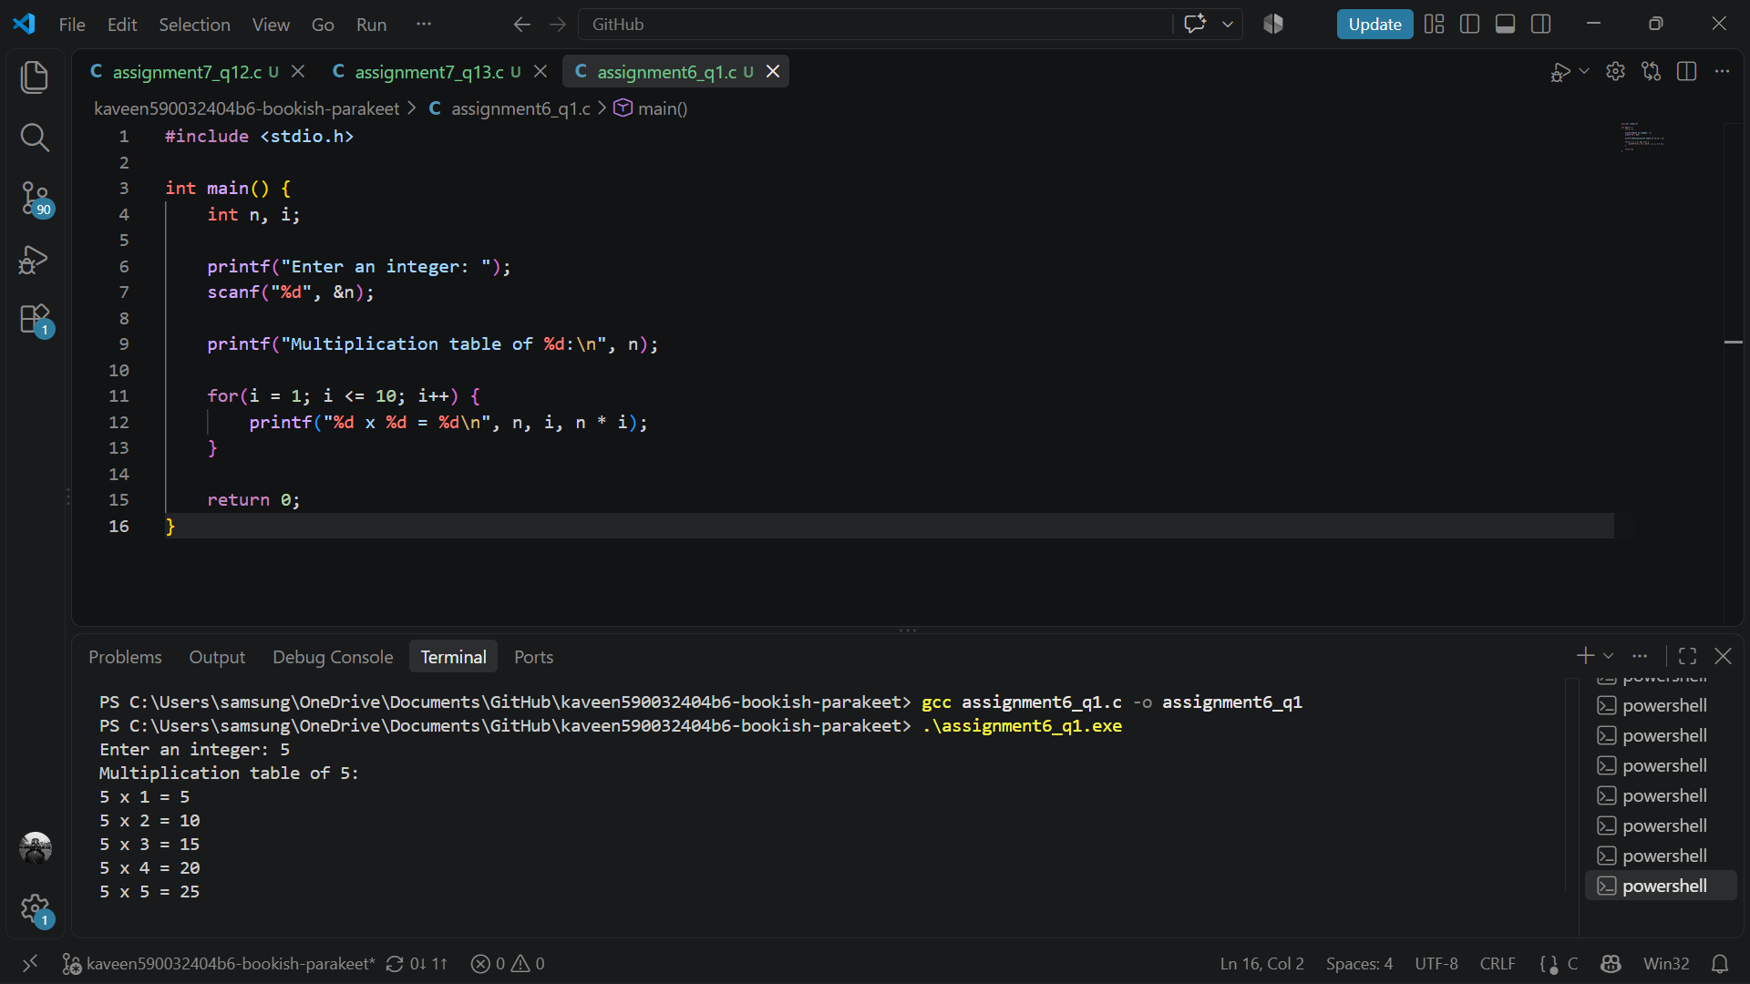
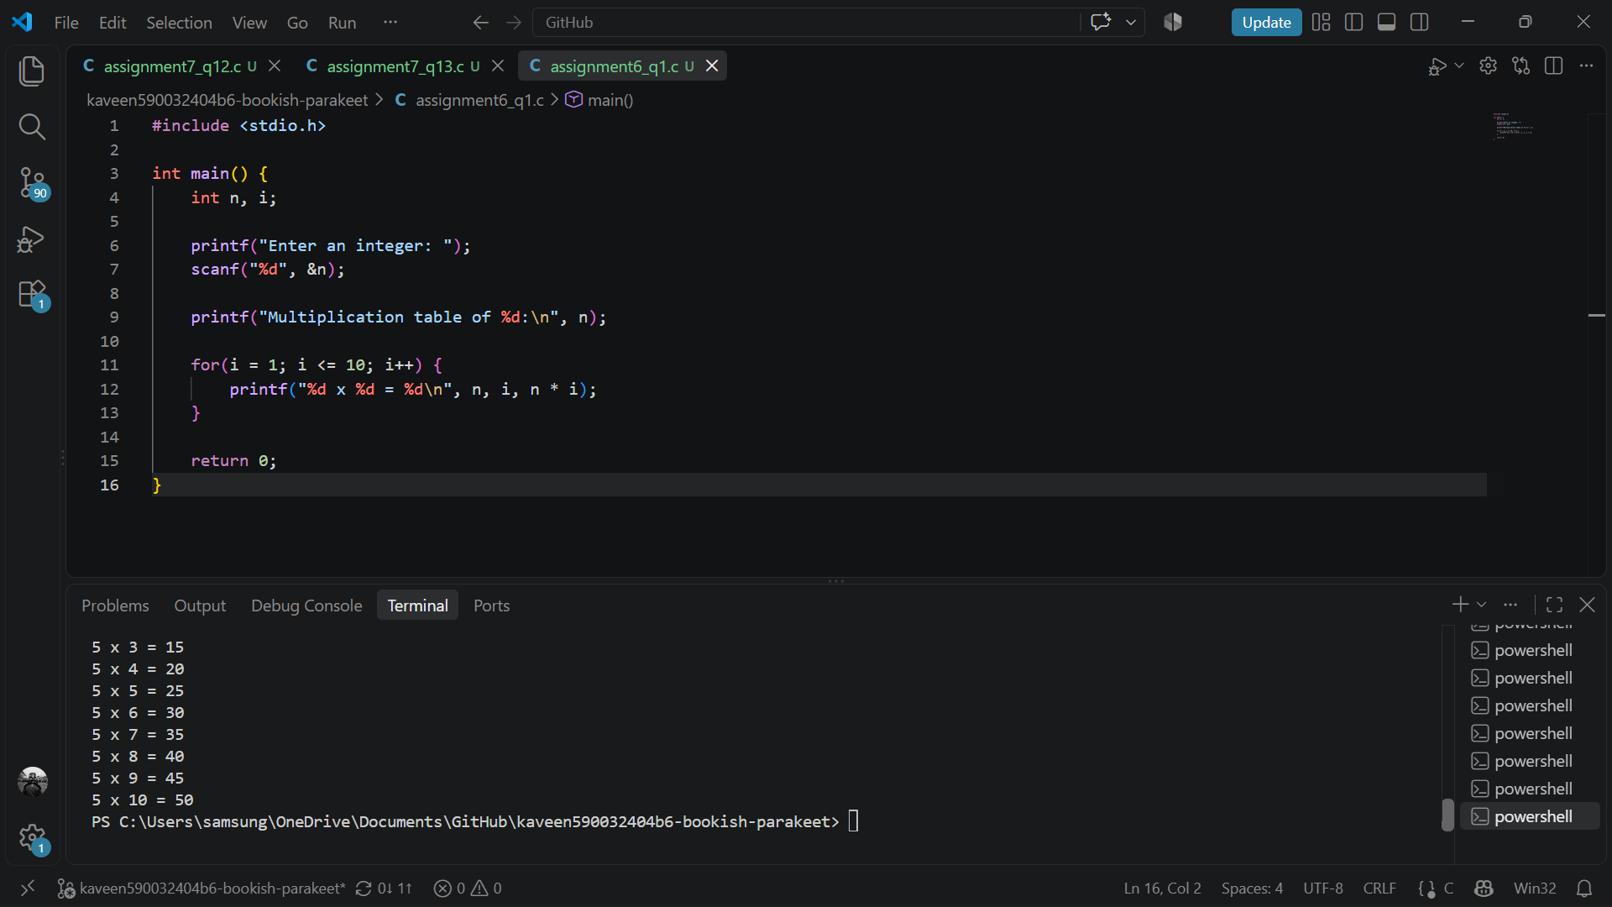

- Fibonacci Sequence
Write a C program to input the number of terms and display the Fibonacci sequence using a loop.
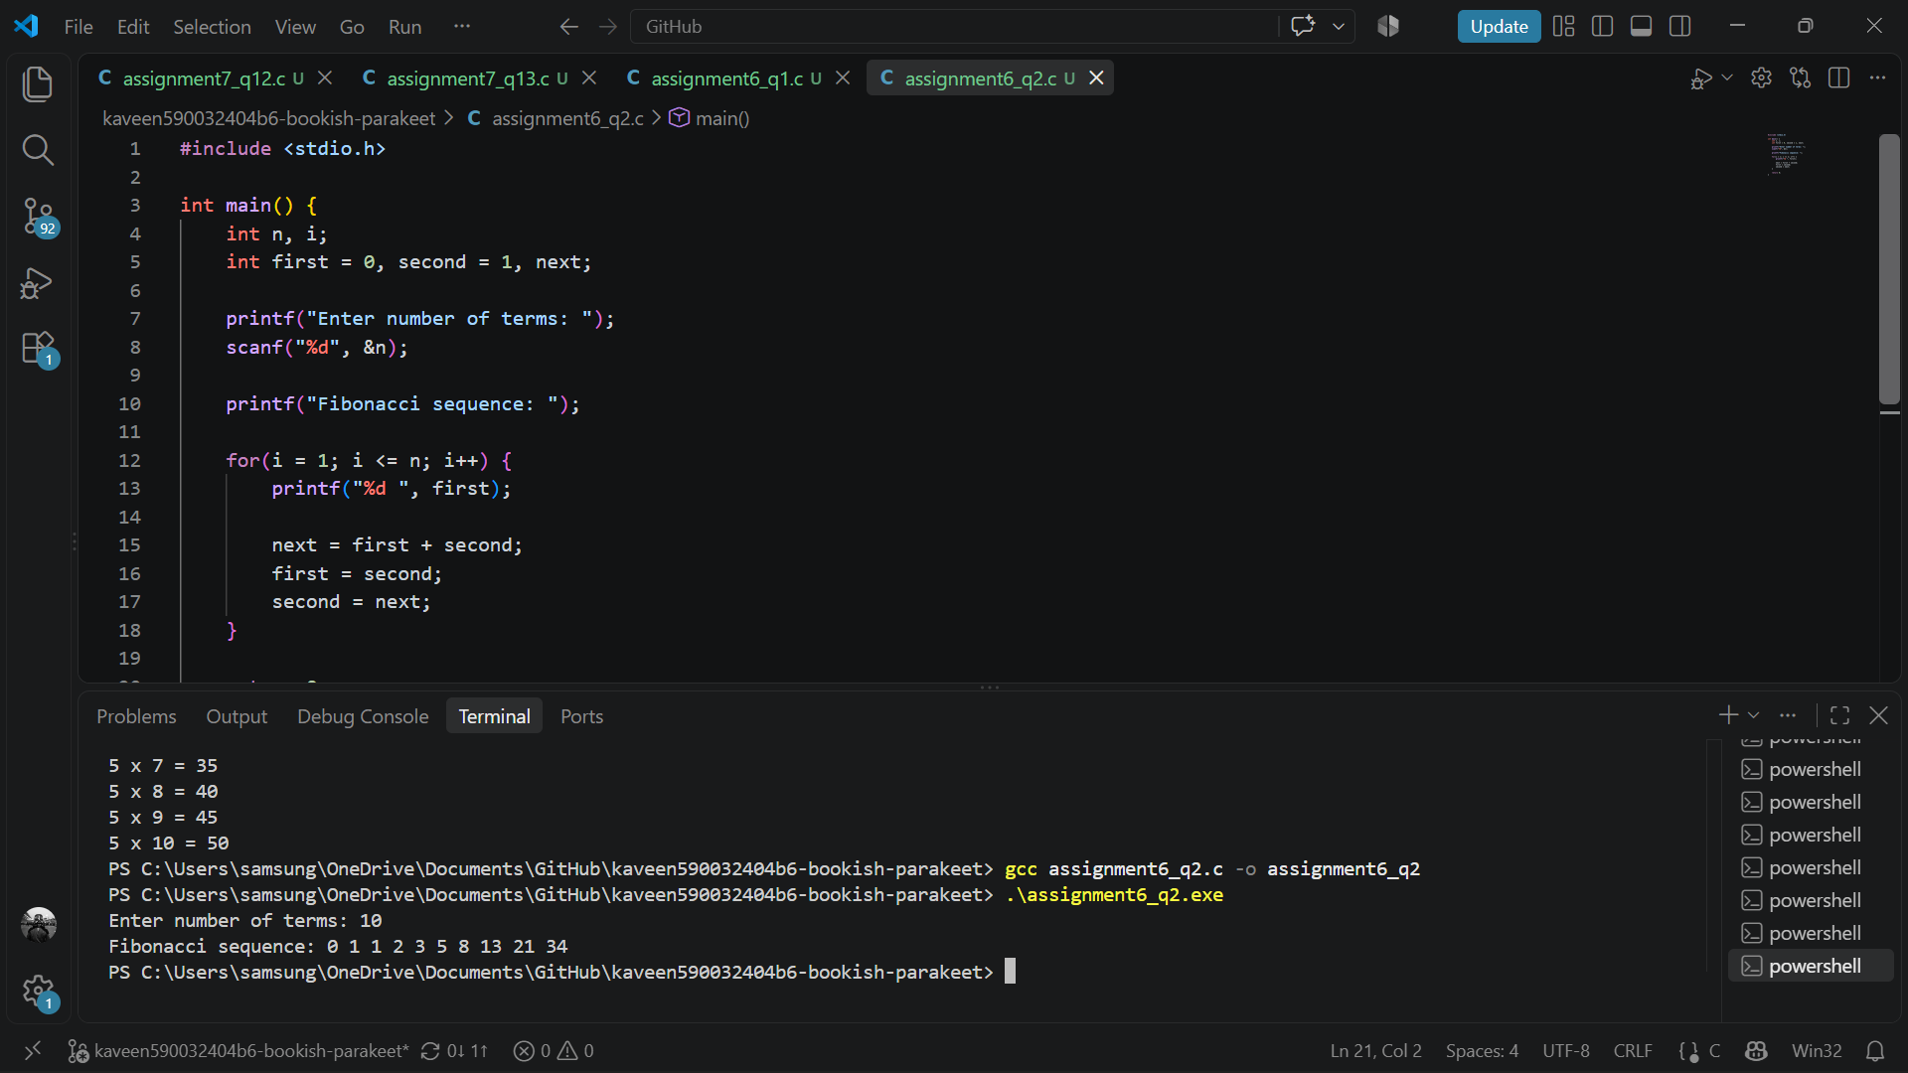
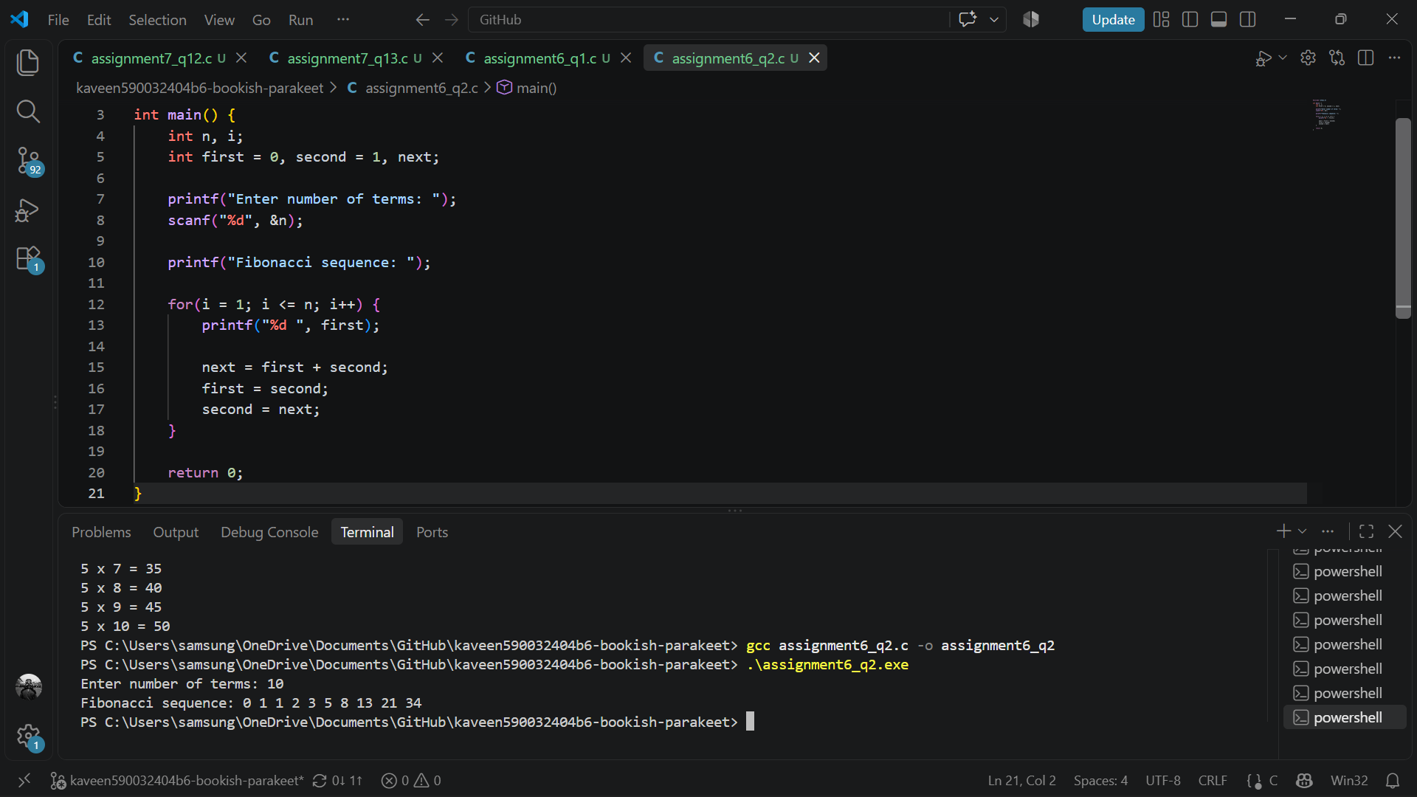

- Palindrome Number
Write a C program to input a positive integer and determine whether it is a palindrome using a loop.
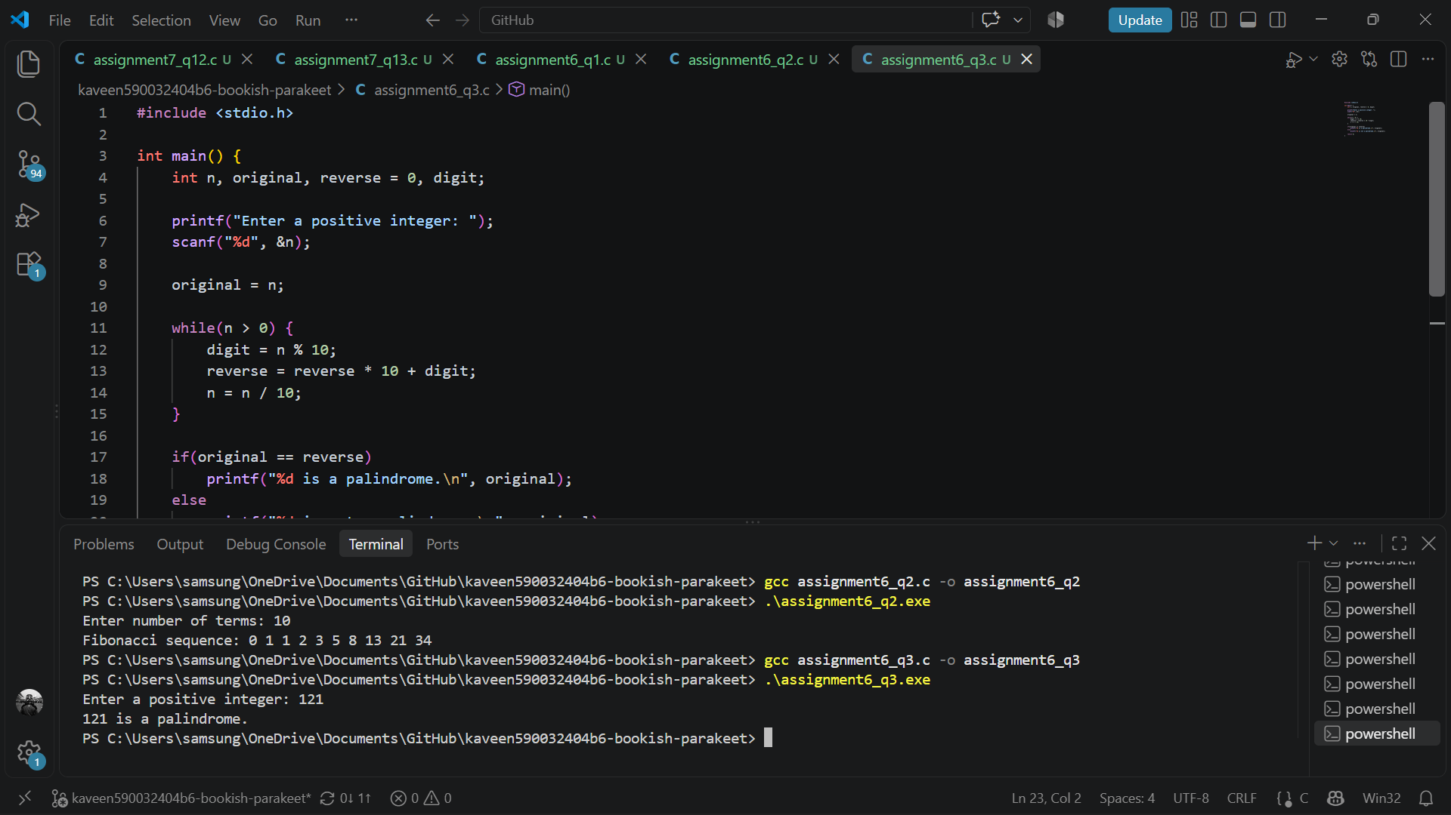
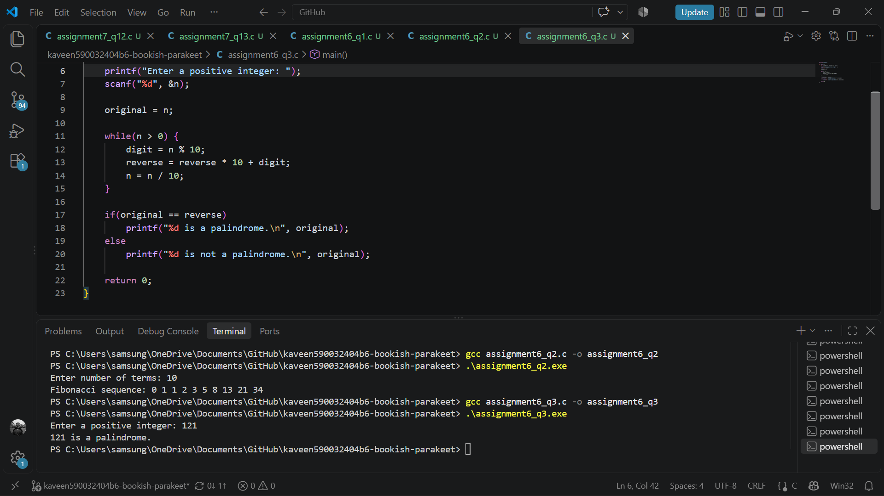

- Perfect Number
Write a C program to input a positive integer and determine whether it is a perfect number. A perfect number is equal to the sum of its positive divisors excluding itself. For example: 6=1+2+3.
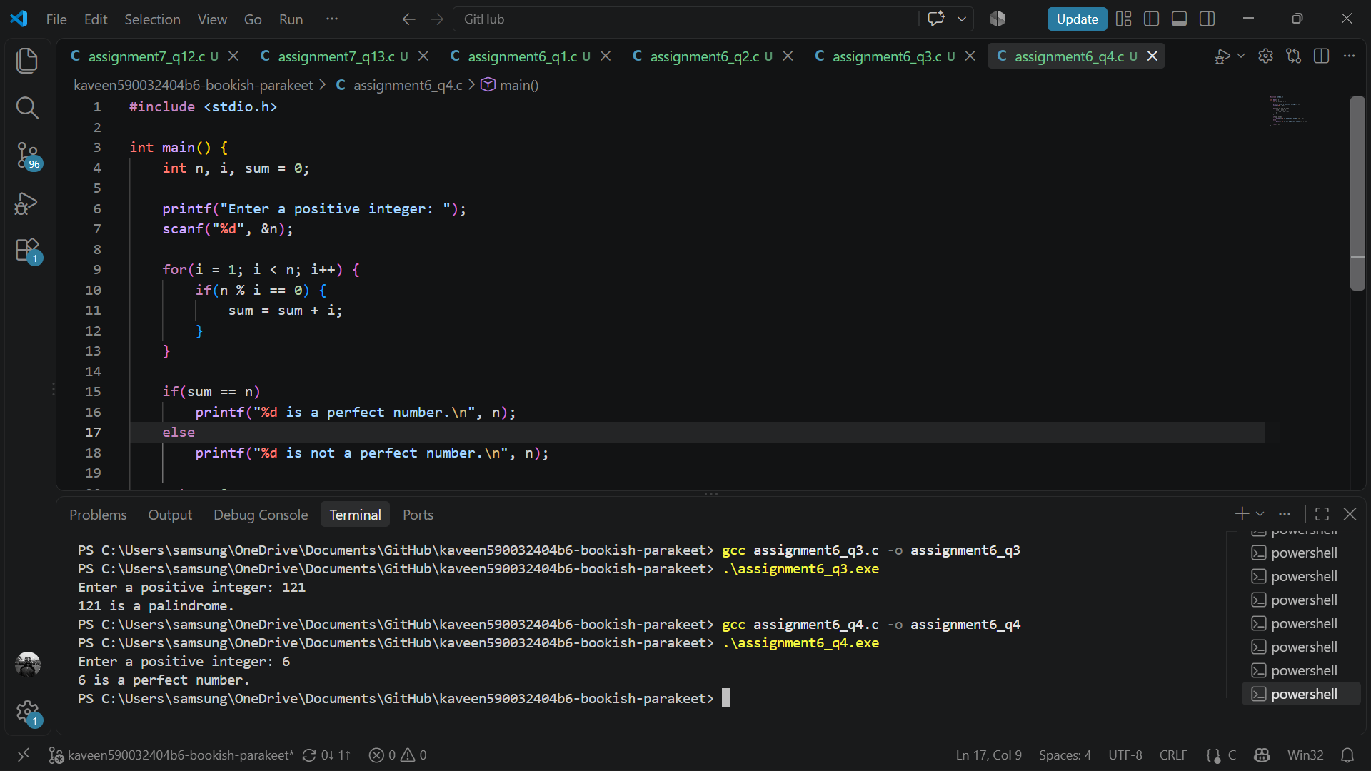

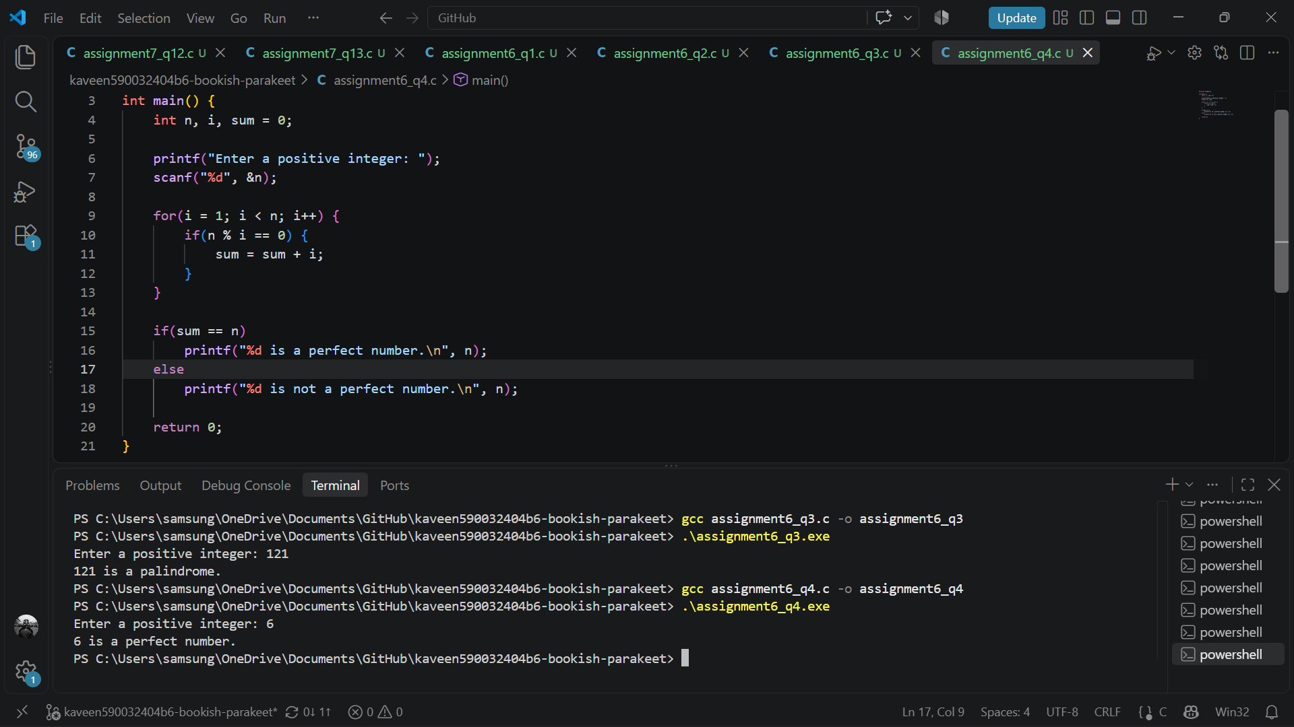

- Prime Numbers in a Range
Write a C program to input two integers representing the lower and upper limits. Display all prime numbers within the given range and print the total number of prime numbers found. Use nested loops.
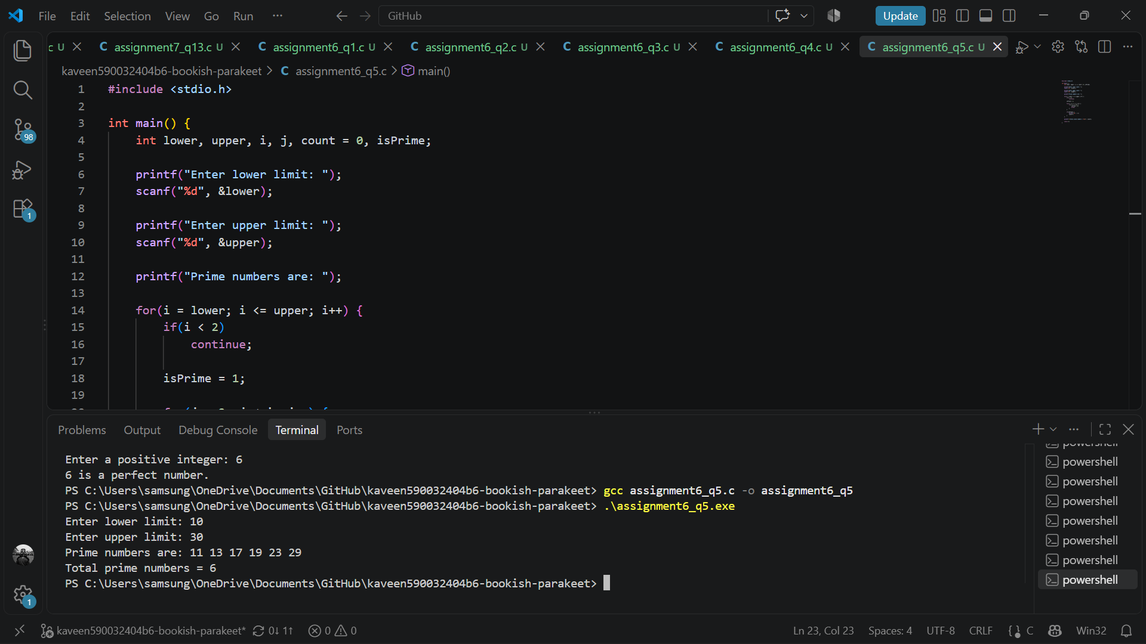
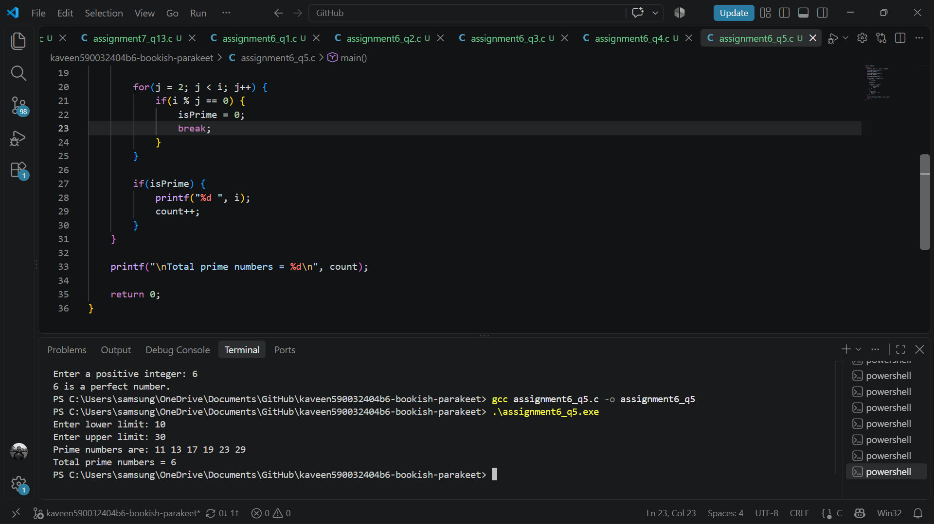

- Pattern Using Nested Loops
Write a C program to input the number of rows and print the following pattern. For n = 5:
1
2 3
4 5 6
7 8 9 10
11 12 13 14 15
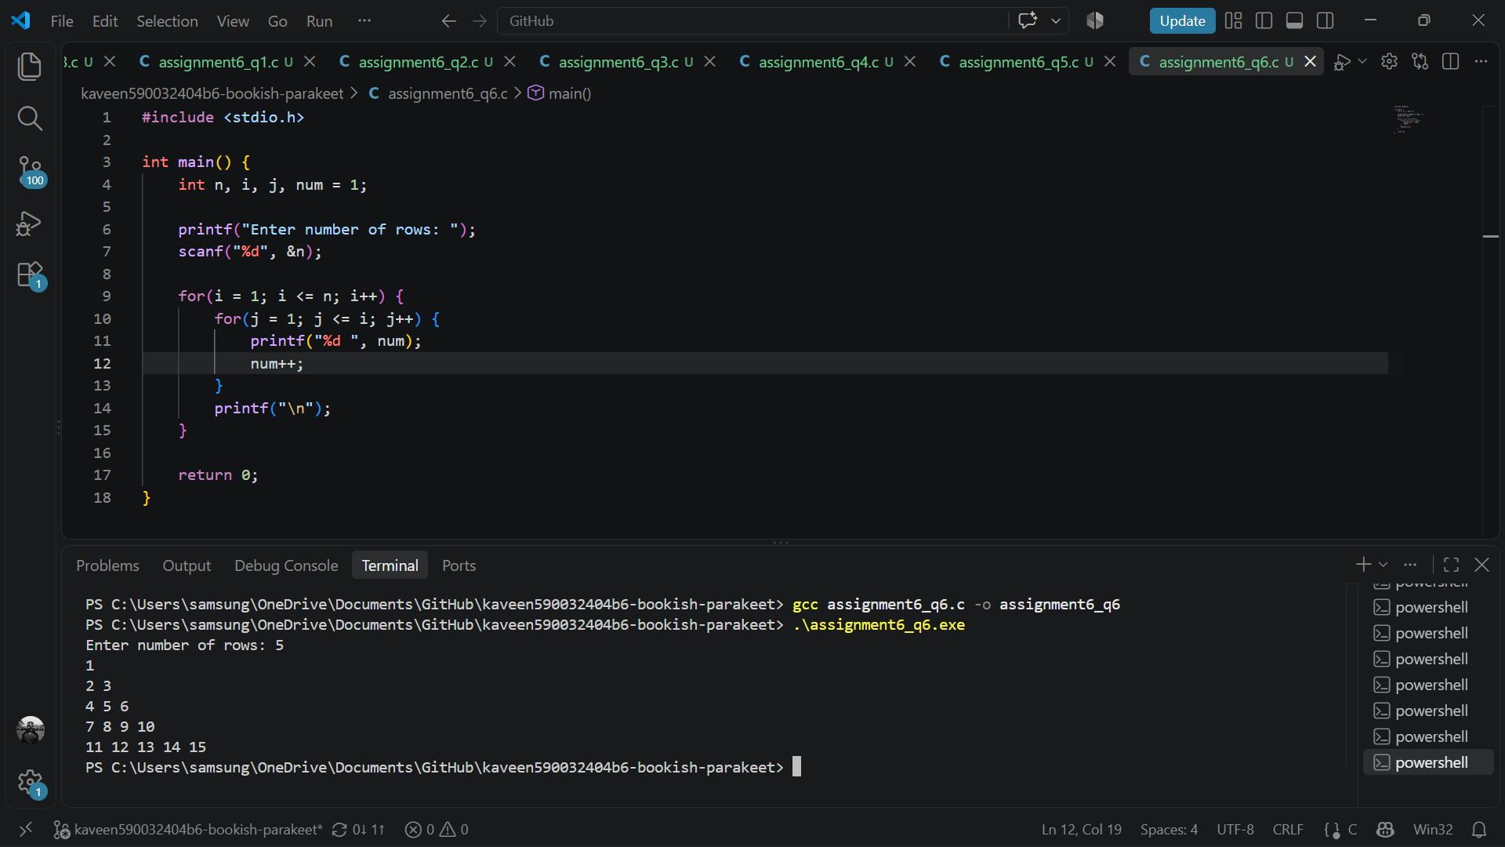

- Decimal-to-Binary Conversion
Write a C program to input a positive decimal integer and convert it into binary using a loop. Do not use arrays, strings, or library conversion functions.
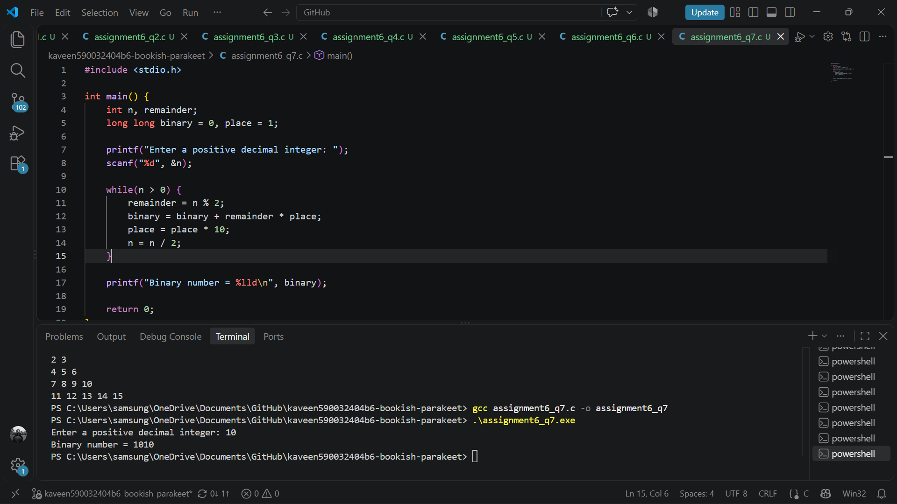

- Series Evaluation
Write a C program to input x and n and evaluate the following series:
S = x − (x^2)/2​! + (x^3)/3! − (x^4)/4​! ​+⋯+(−1)^(n+1) (x^n)/n​!.
Calculate powers and factorials using loops without using pow() or a separate user-defined function.
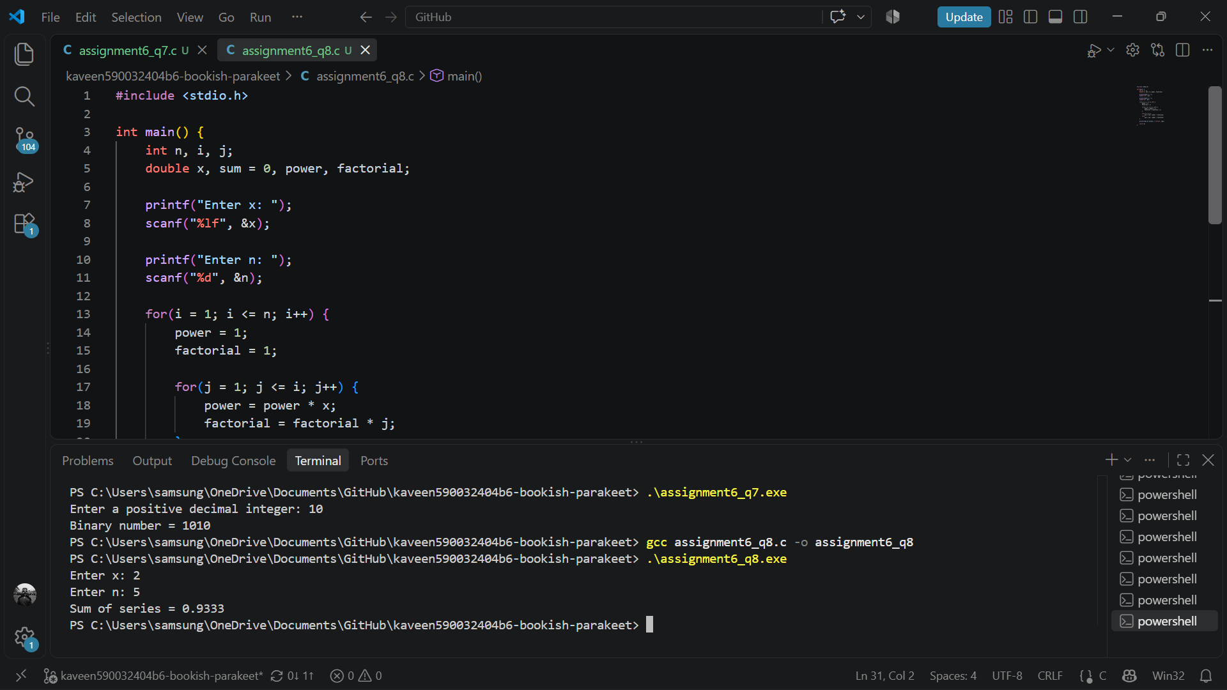
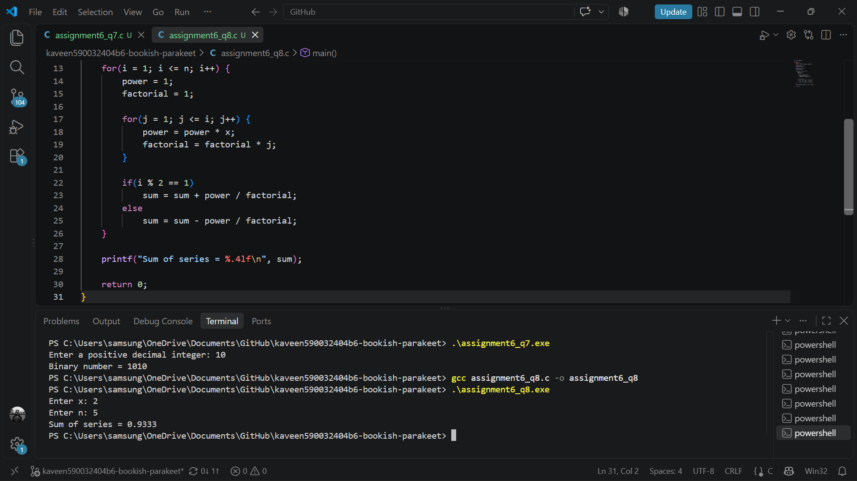

- Menu-Driven Number Operations
Write a C program that repeatedly displays the following menu:
1. Check Palindrome
2. Check Armstrong Number
3. Check Prime Number
4. Find Sum of Digits
5. Count the number of Digits of an integer
6. Exit

Requirements:
- Use a do-while loop to display the menu repeatedly.
- Use switch-case to perform the selected operation.
- Continue until the user selects Exit.
- Display an error message for an invalid choice.

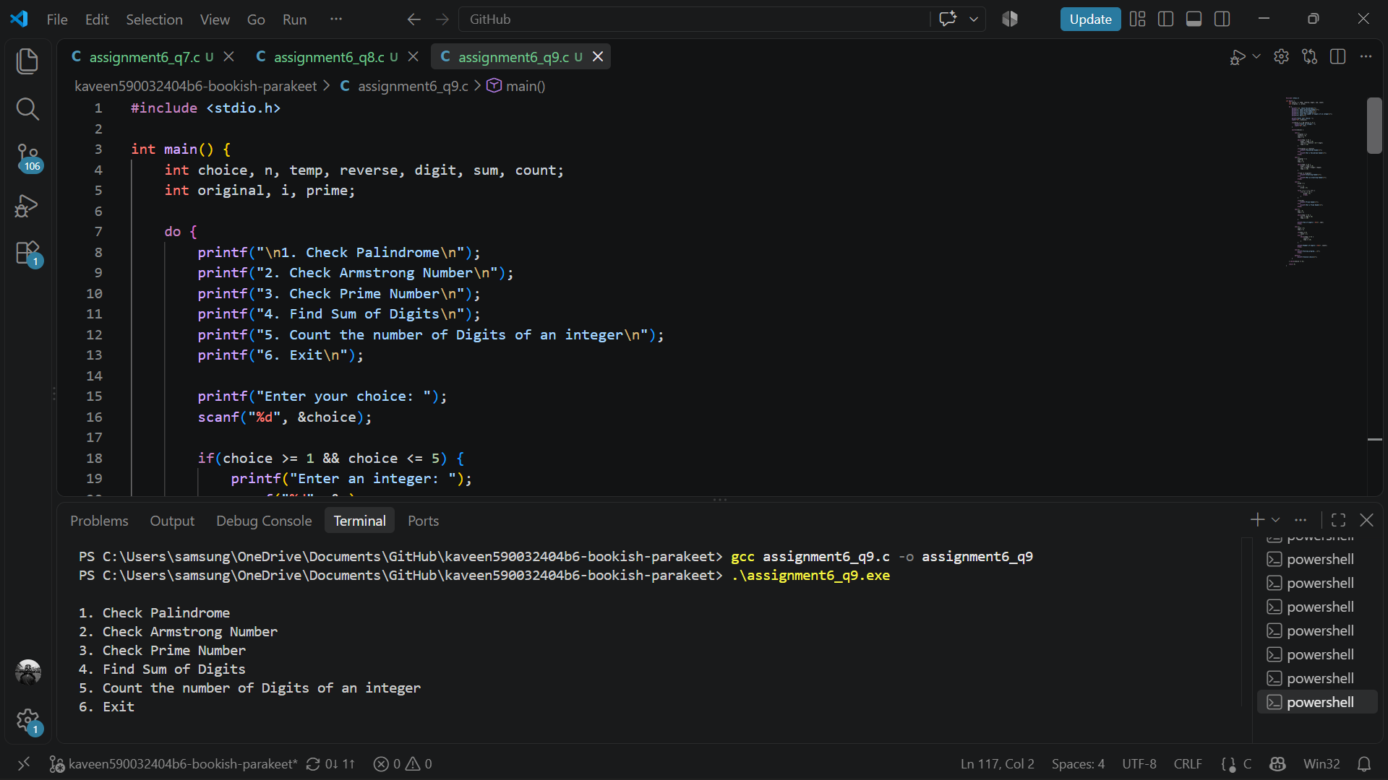
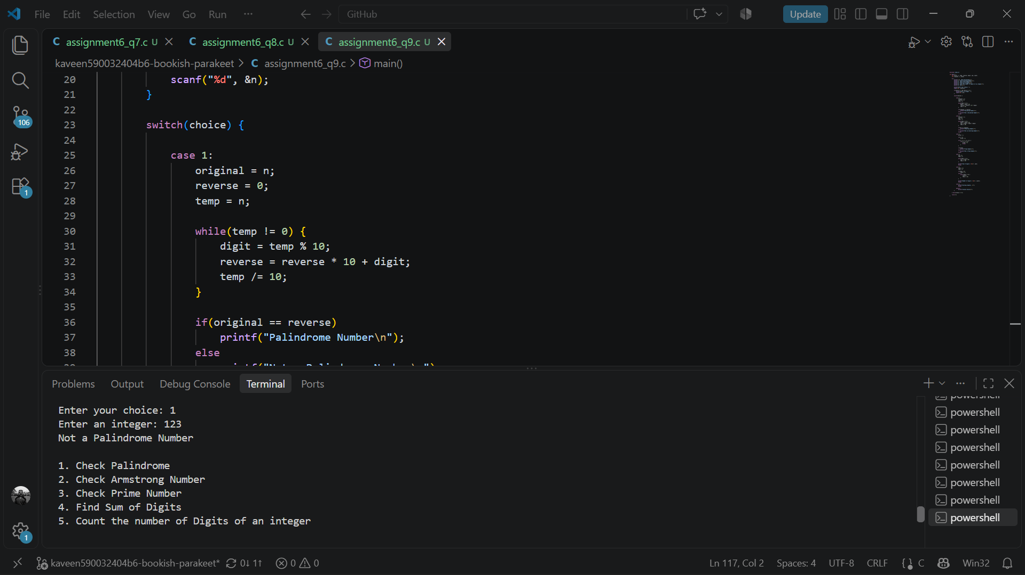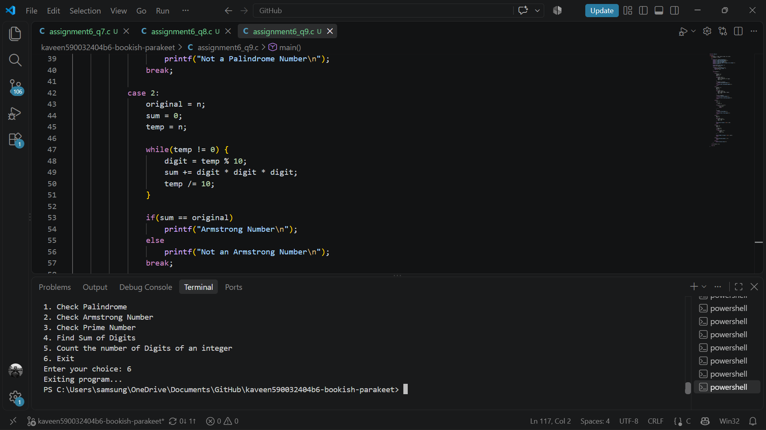
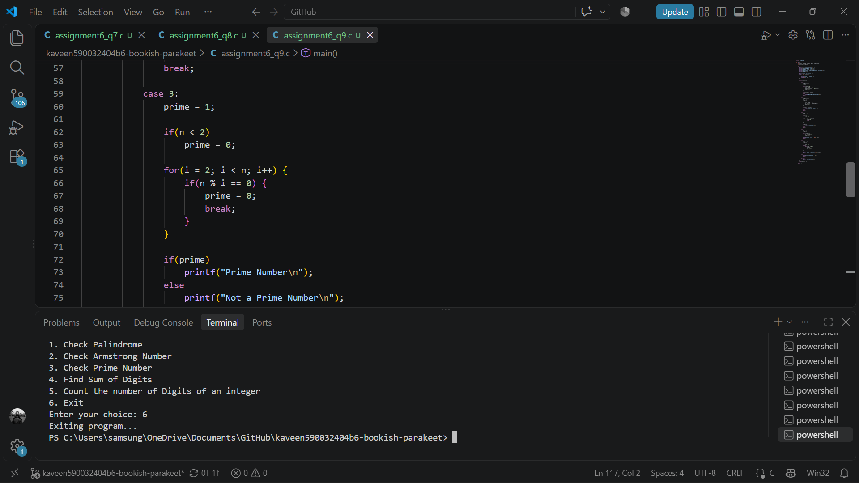
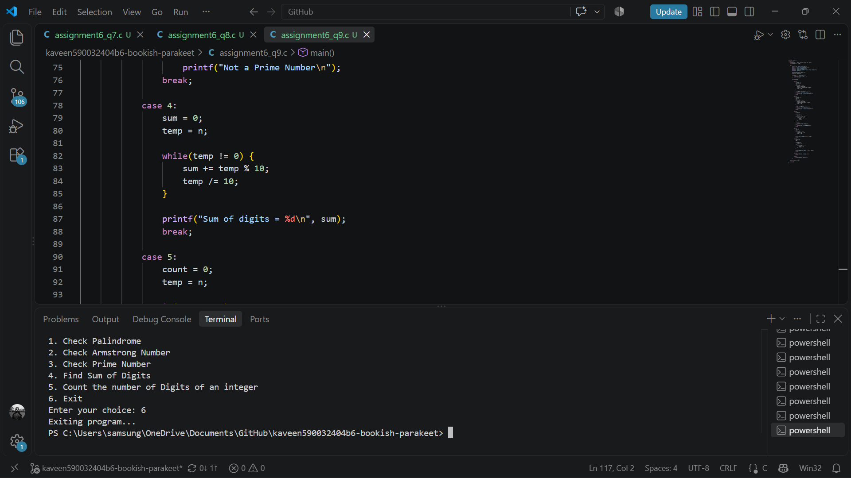
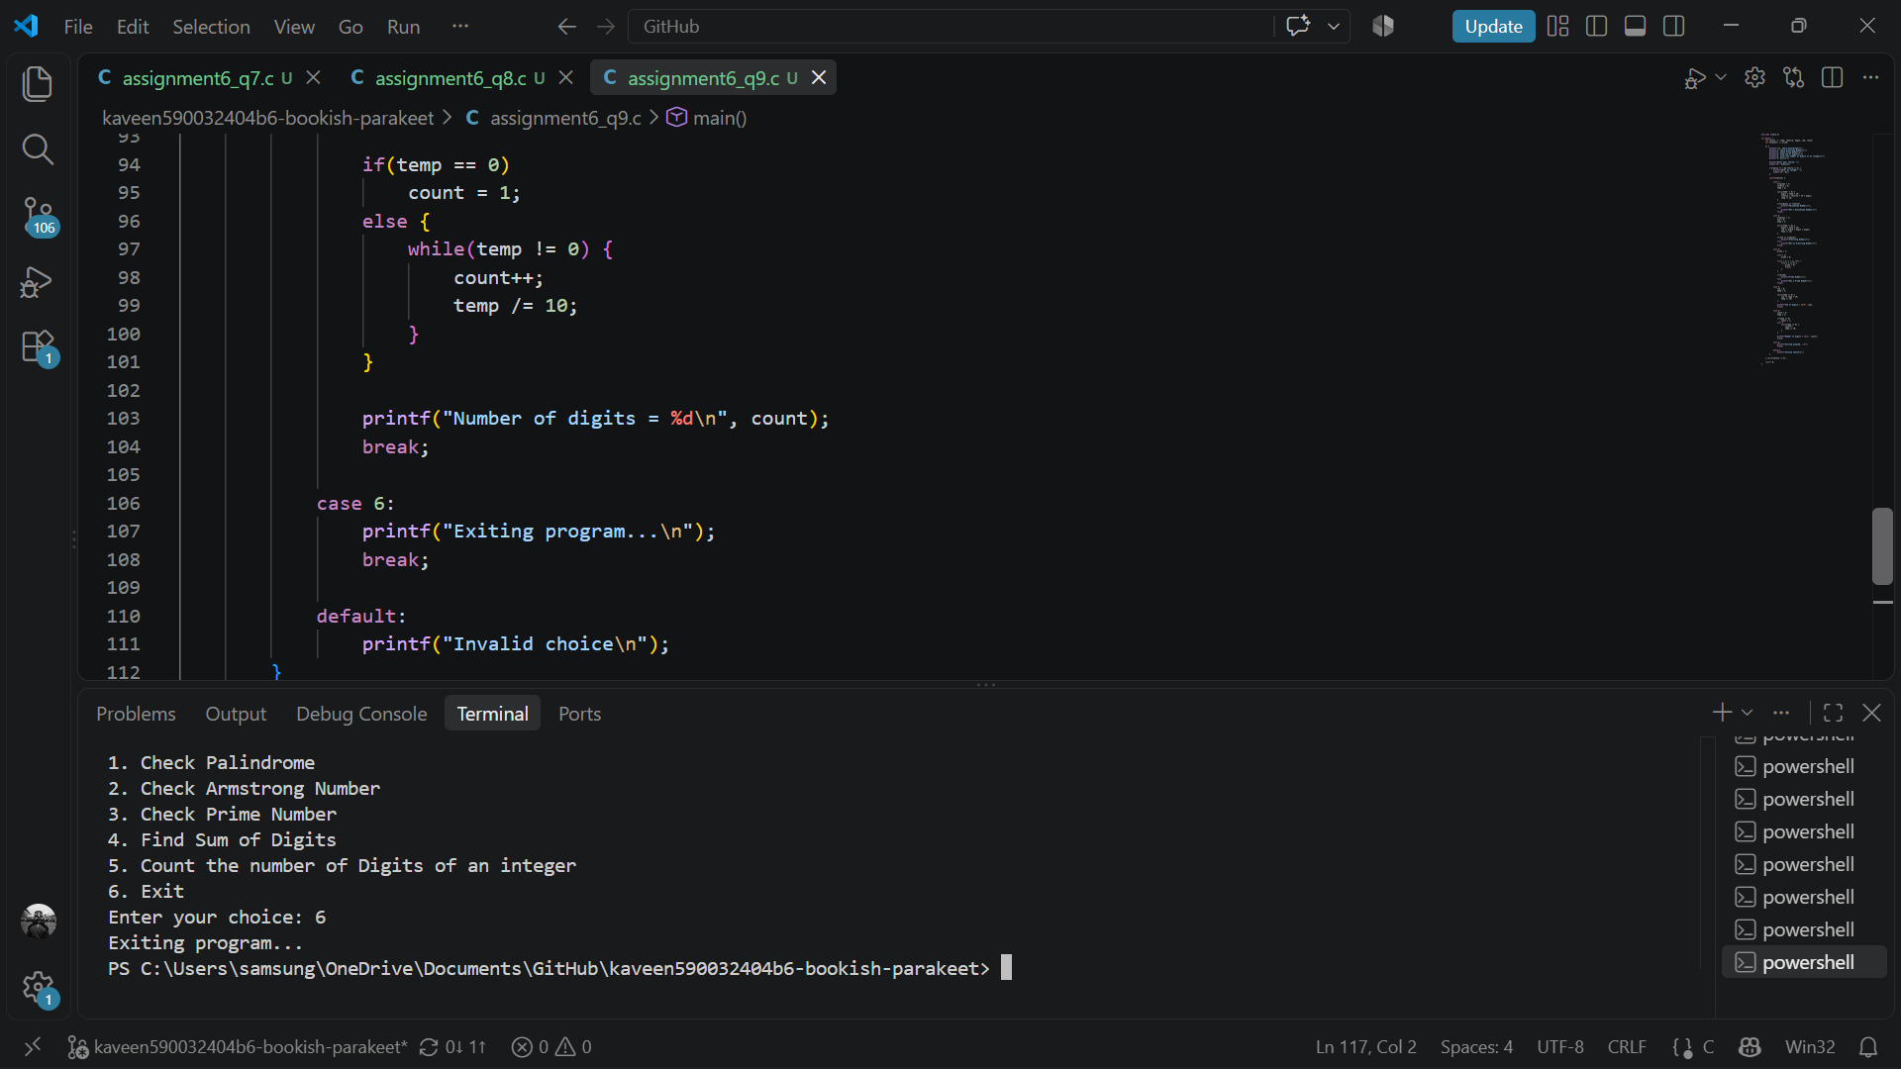
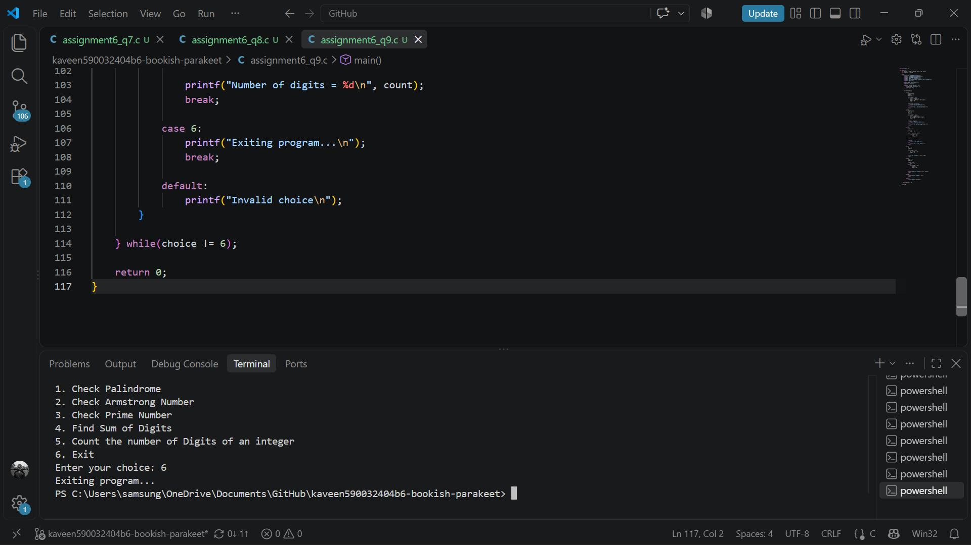

- Pascal’s Triangle
Write a C program to input the number of rows and display Pascal’s Triangle using nested loops.
For n = 5, the output should be:
1
1 1
1 2 1
1 3 3 1
1 4 6 4 1
